Observations: **(As discussed with Chhaya this is not an issue w.r.t Home Page Changes)>>Update received from Bansil**  
  
Search functionality and predictive search not working

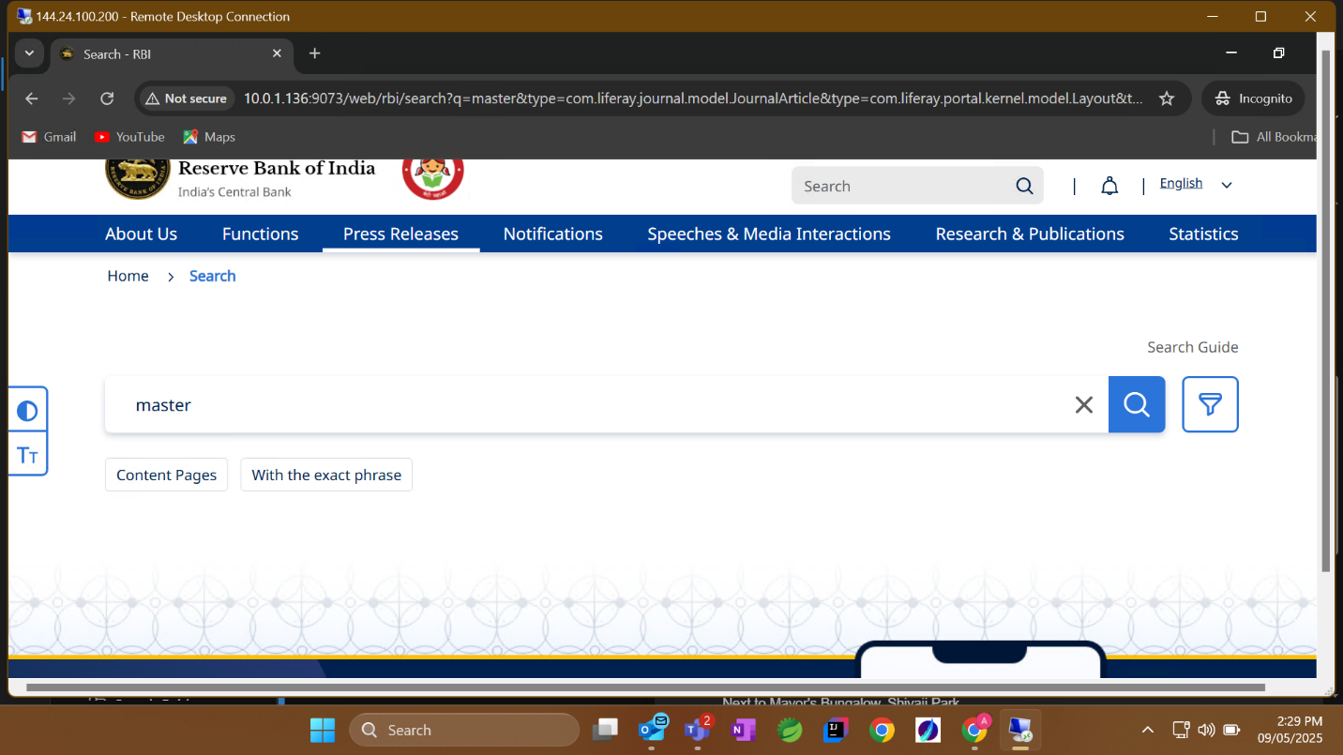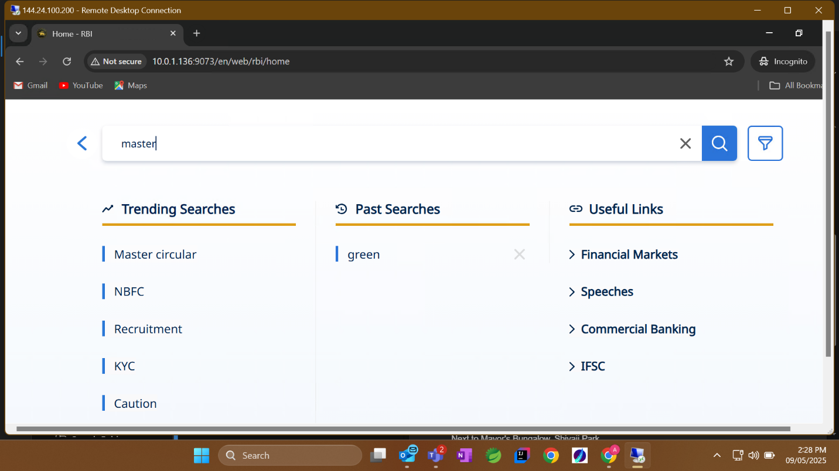

Content in English for Hindi Page>**>Content issue (Not an issue)**  
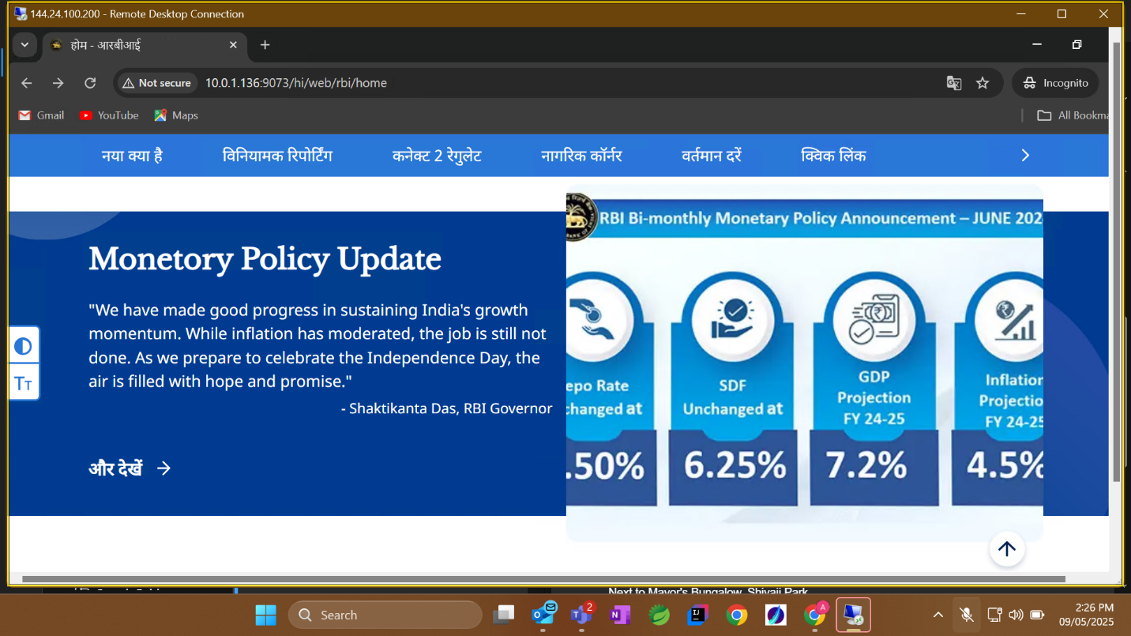

Content is missing for Hindi>>**(Need to fix)**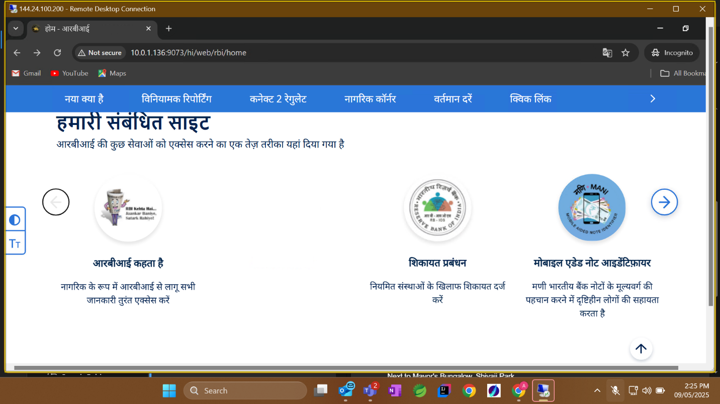

Conetent in English for Hindi>> **>Content issue (Not an issue)**

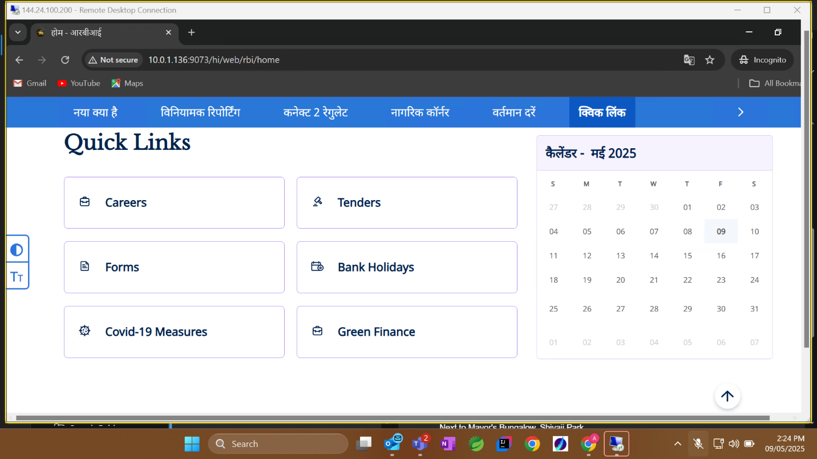

Numbers are in Hindi literature in Graph legand**>>(As per the implementation**)  
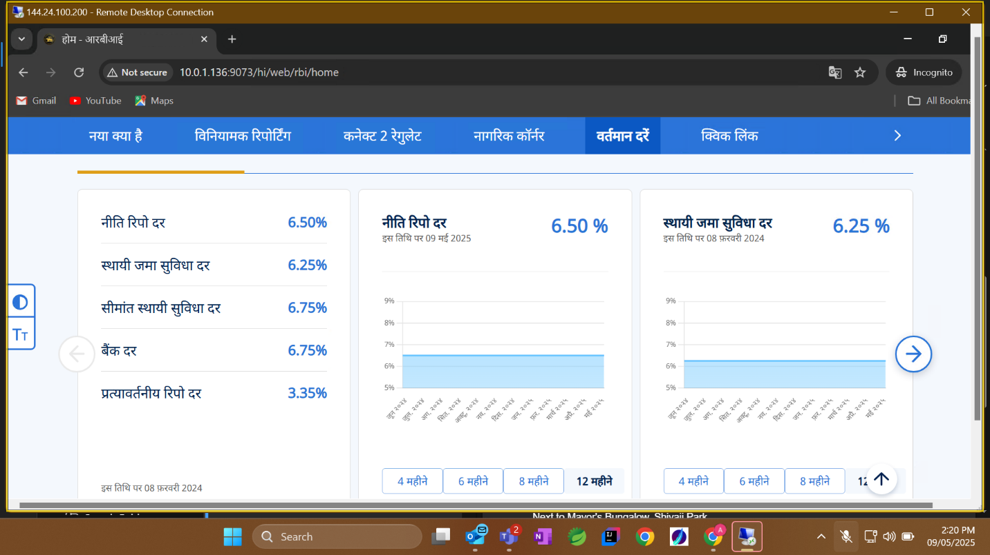

Content in English for Hindi>> > **>Content issue (Not an issue)**

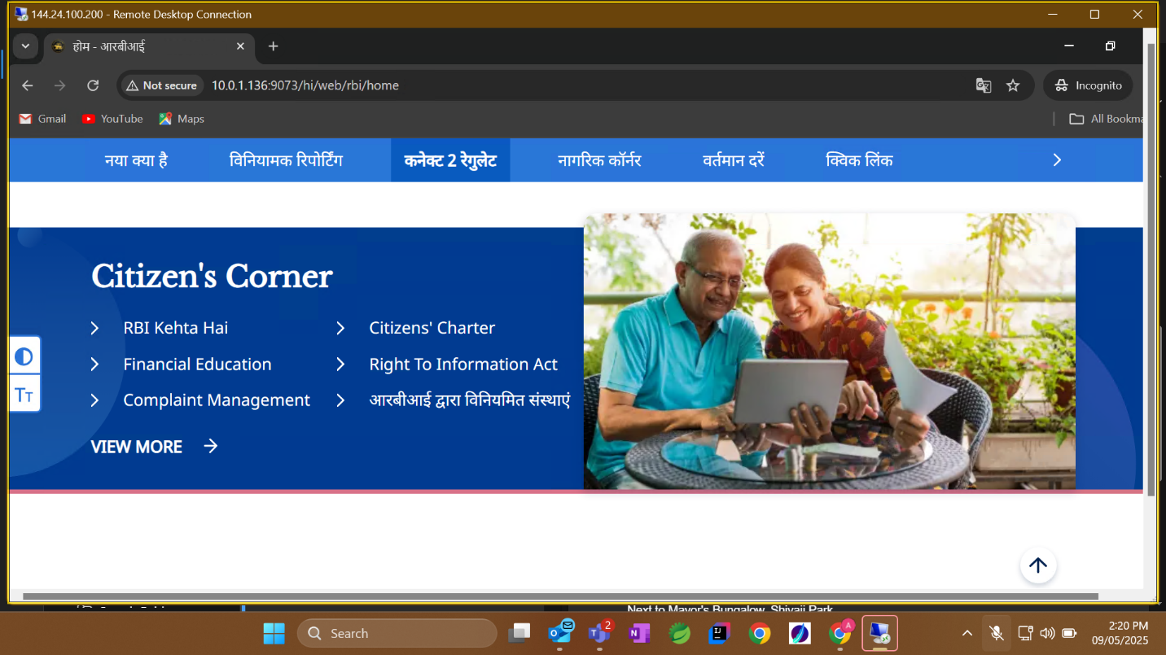

Images and videos are not loading for Hindi Page>**>(Not able to replicate the same now)>>Fixed**  
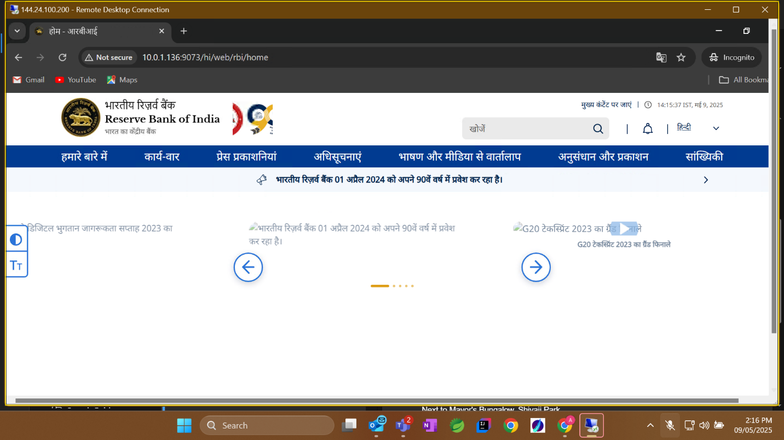  
Empty page**>>> (Content issue)**  
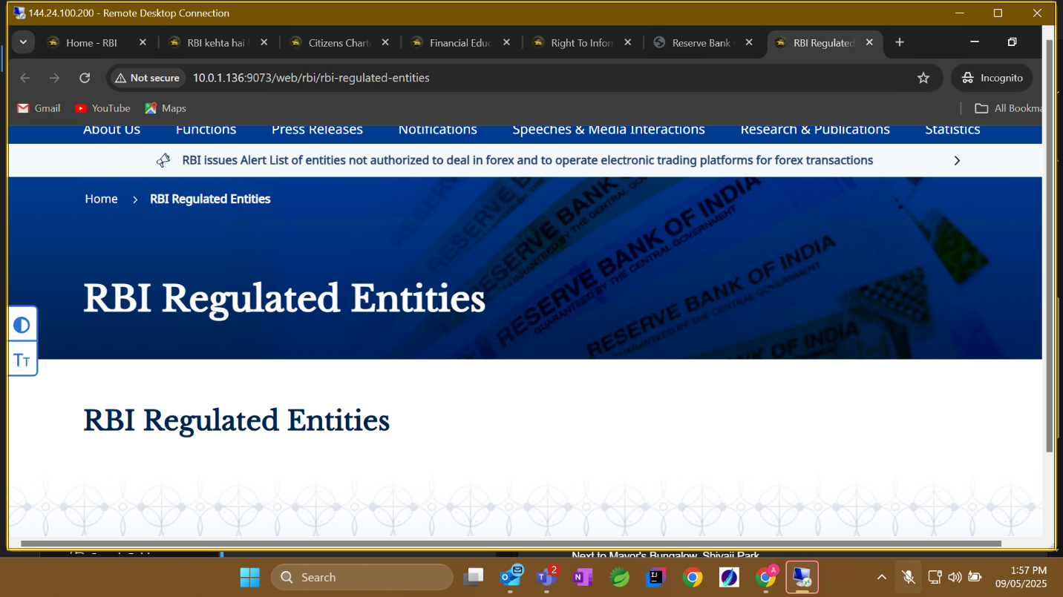

Search functionality is not working>**>(As per parth this is not in scope for testing wrt the Home Page Changes)**  
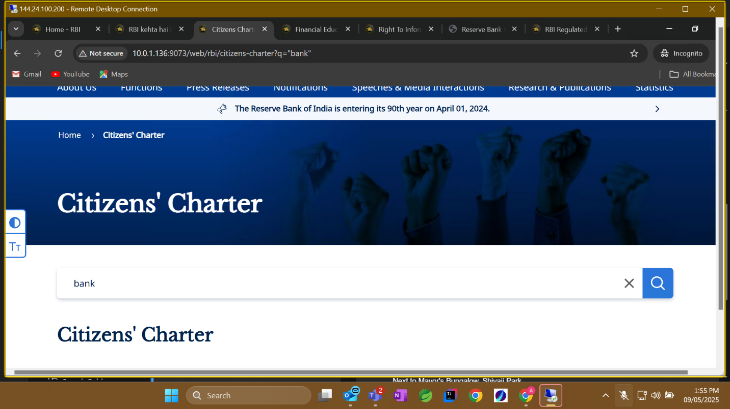

Dummy entries (not same as prod)>>**(Content issue)**

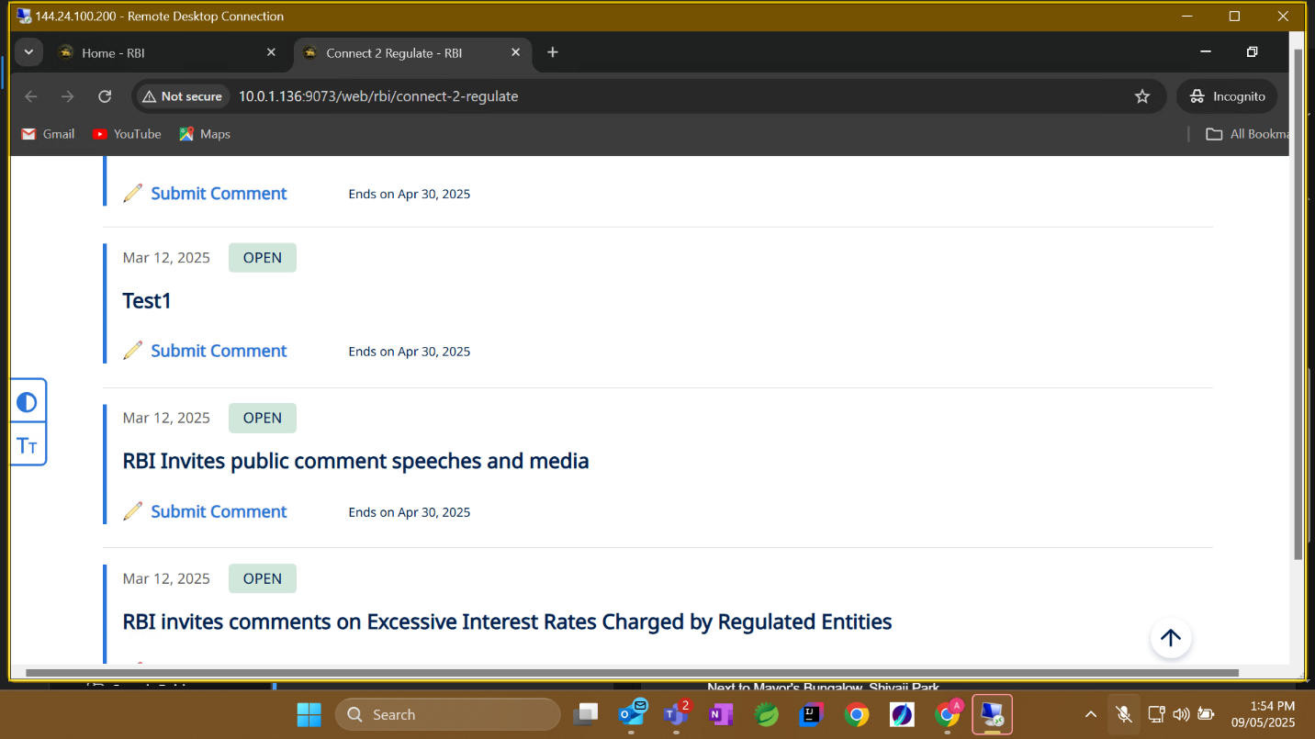

Empty **>>(Not an issue)**

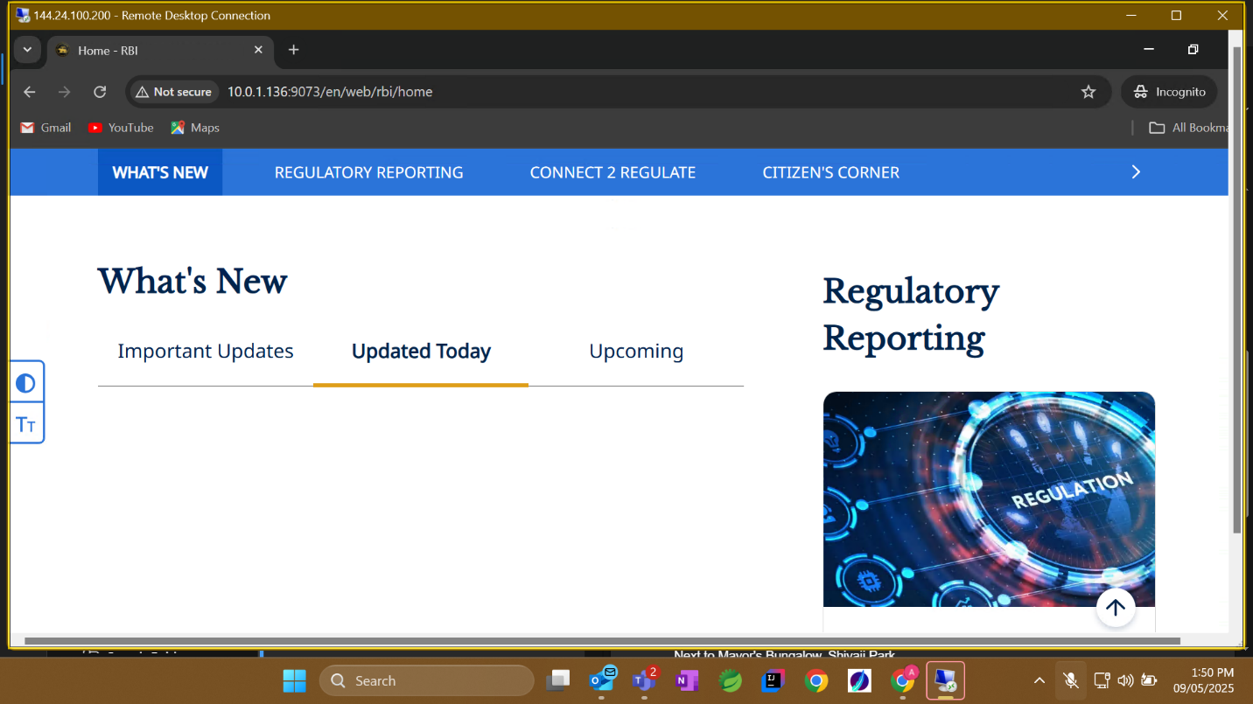

“No data available for upcoming section” this text is misaligned>**>(Need to fix)>>Already BUG id is present against this>>Fixed in SIT Q4.4**

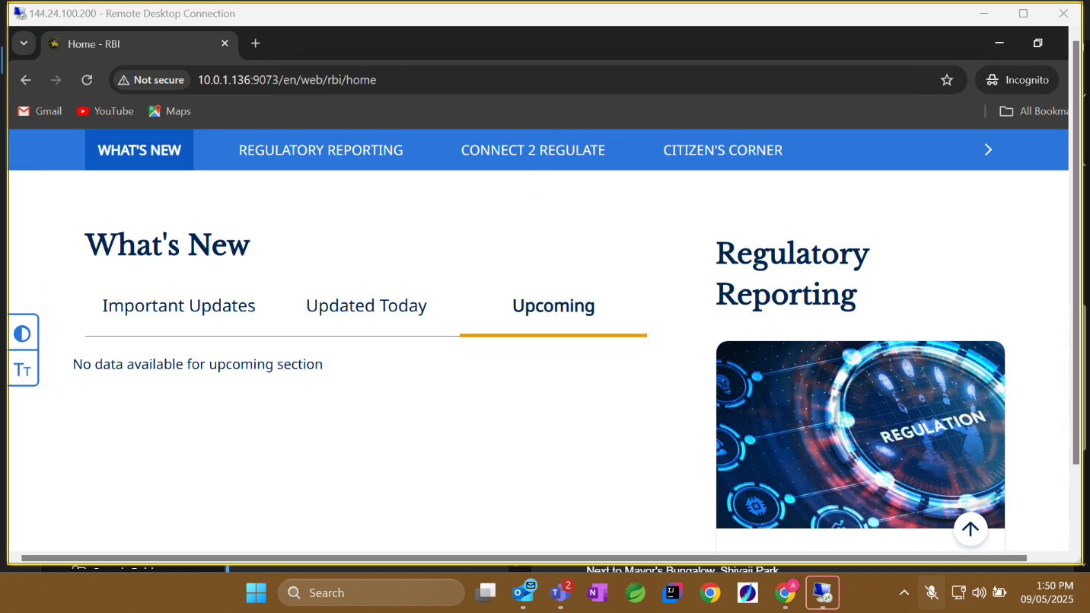  
Have entered OTP only for onec but it says exceeded the limit already**.(As per parth this should not be in scope for testing wrt changes done ffor Home Page)**   
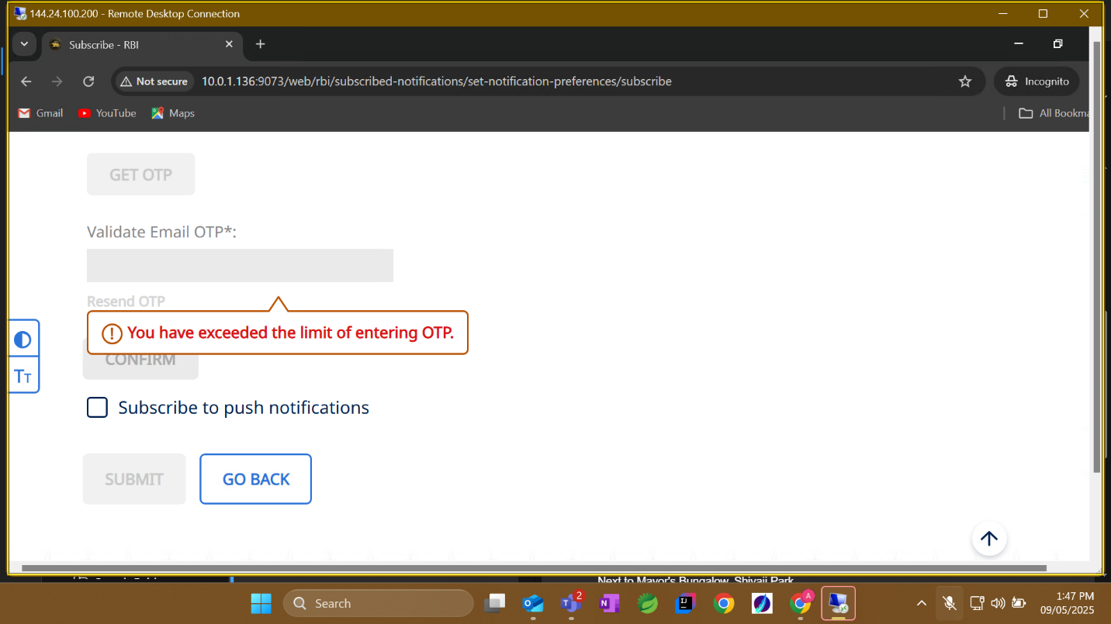

RBI@90 has no link>>**Fixed**

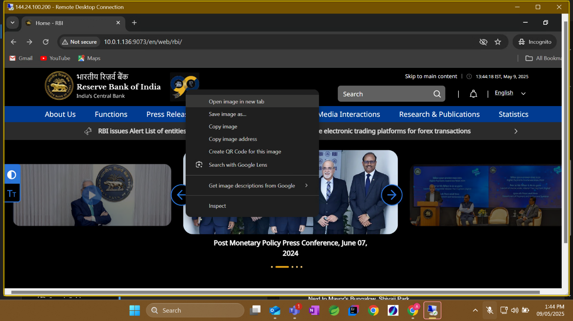  
No data in RBI Bulletin Page>**>(As per parth this is not in the scope for Home Page changes)**  
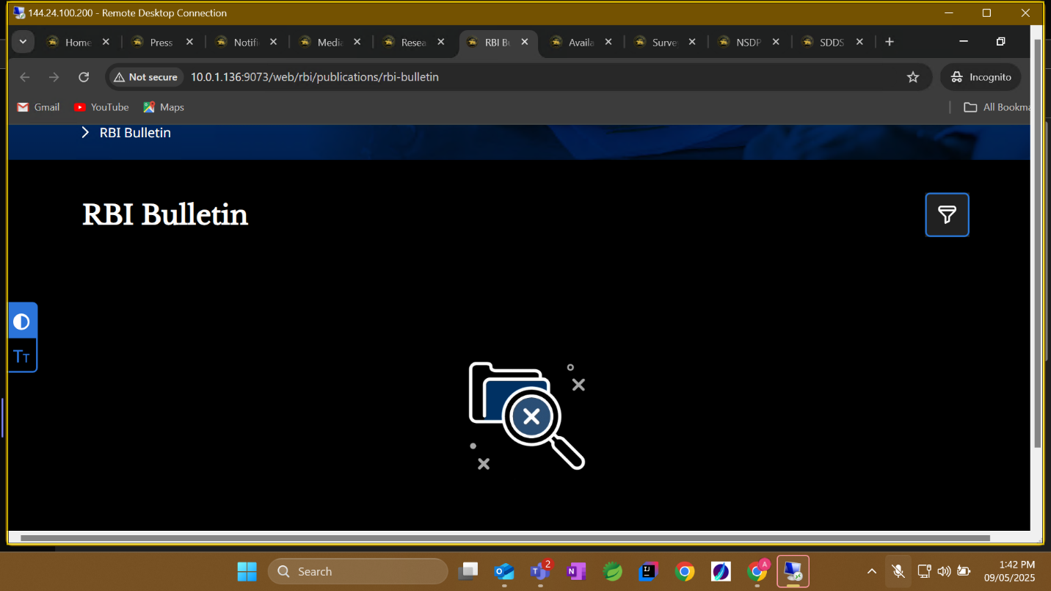

Invalid pdf size >>**(Need to fix)>>(This is not in scope for Home Page testing)**

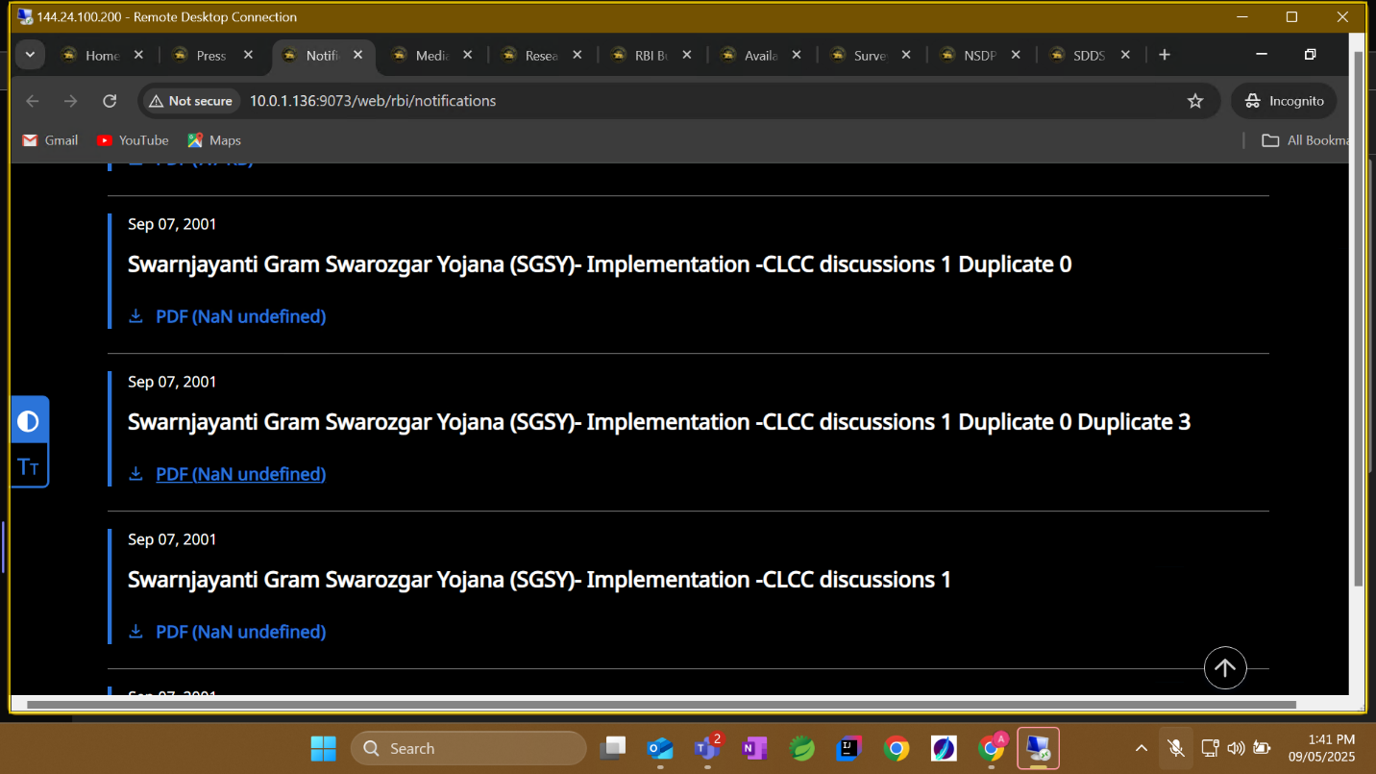

No graphs>**>Need to fix**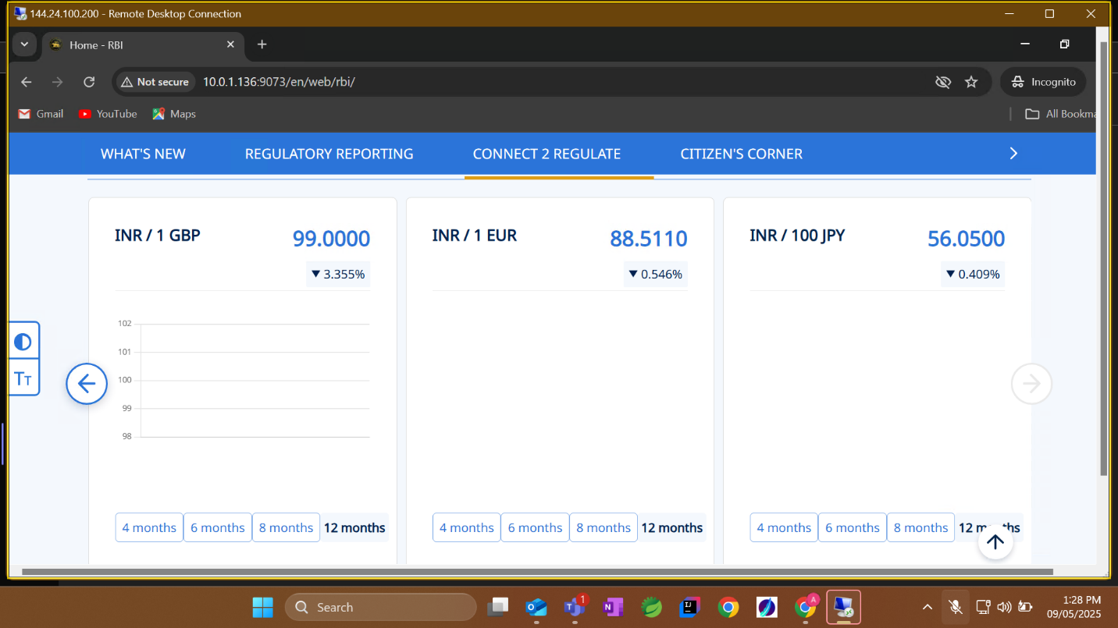

Recent Speeches section is not there.**(Need to fix)>>Remove option from sec nav**

